**Тема:**  «Основные понятия и сокращения в электротехнике»

**Цель:** Повторить грамматический материал , продолжить изучать лексическую тему «электричество, основные понятия и сокращения в электротехнике».

**Задачи:** Отработать навык работы (в т.ч. перевода) с профессиональной лексикой по теме «электричество», повторить тематический материал, актуализировать имеющиеся знания.

**Специальность:** 13.02.09 Монтаж эксплуатации линий электропередачи, 13.02.11 Техническая эксплуатация и обслуживание электрического и электромеханического оборудования (по отраслям)

**Время выполнения:** 180 минут

1. **Work with the glossary**
2. **Read the text**
3. **Memorize the rule**
4. **Do the tasks**

**Learn the basics, read the signs.\***

*Electrotechnics belongs to the most progressive evolving field. It was necessary - for example, due to the need to correct translation of the instructions for use, service manuals and so on – to introduce a uniform language.* The IEC organization is responsible for the unification of the terminology and it issued and updates the International Electrotechnical Vocabulary IEV [International Electrotechnical Vocabulary](http://www.electropedia.org/). The dictionary contains a precise definition of each item and each has its own specific numerical code for your comfort. Being a professional electrician envolves you into the amazing but still hard and a bit messy world of terminology. *Some must be learnt by heart, some must be recognizable, and only few can be let being unknown*. And what is more essential, awareness at abbreviation, symbols, marks and units are of the same importance!

**Signs** and connections used in the electrical system are set out in the standard STN IEC 60617.

We distinguish the *standardised* signs:

1. general (basic) – common for a group of components with the same function
2. complementary – they specify the meaning of general signs

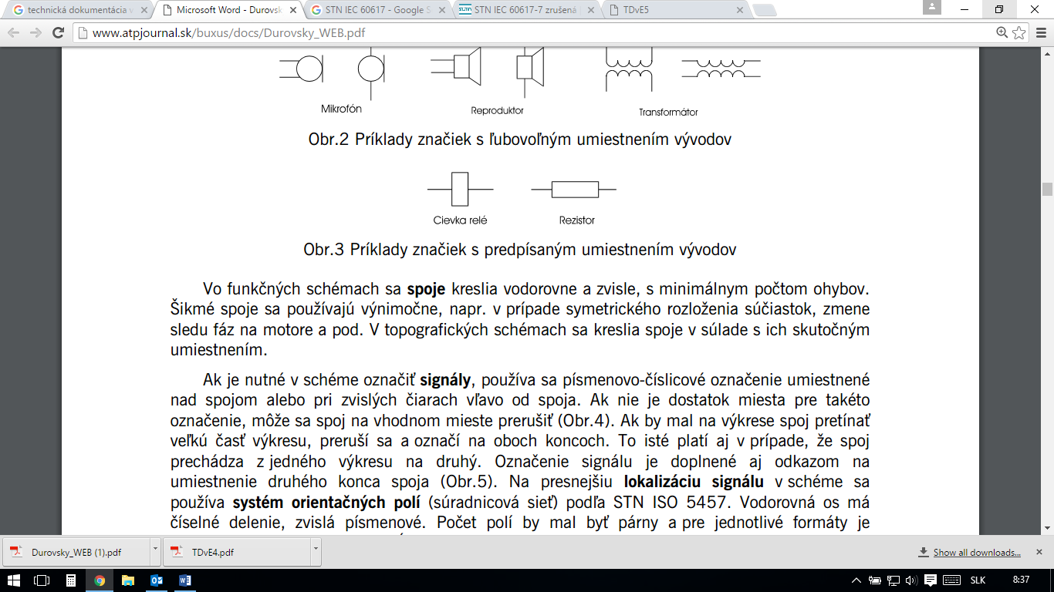These signs can be mutually combined to clarify the meaning. There are also *non-standardised* signs used by individual producers and they can be found for example in product catalogues. In the STN EN 60617 there are some of the signs introduced without outlet. If the sign is in the standard specified with outlet, their position must be maintained, as this could cause confusion between the signs, for example the relay coil and a resistor.

*a – relay coil*

*b – resistor*

## Lines. Electrical schemes usually use one line thickness. Exceptions represent, for example, the main or power circuits, which are plotted with a thick line. It is recommended unified line thickness when using CAD systems. Tab. 1 shows examples of using different types of lines:

|  |  |  |  |
| --- | --- | --- | --- |
| ***Line thickness*** | ***thin*** | ***thick*** | ***very thick*** |
| ***Line type*** |  | | |
| ***full*** | electrical connections generally | main circuits | bus bar |
| electrical connections generally | bus bar | harness |
| reference line | harness | electric wiring by distinguishing the type |
| ***dashed*** | non-electric connections |  |  |
| ***dot chain*** | bounded parts of appliance |  |  |
| earthed protective wire |  |  |
| ***dotted*** | Repetition of parts of circuits |  |  |

## Values and units, indices. Physical quantities are used to describe the properties of devices, products or materials. Units are used to express their size. These are listed in the International System of Units SI. Physical quantities referred to in this system are:

* independent of each other - basic. *In electrical engineering there are used 4 basic parameters (length, mass, time, electric current);*
* derived from the basic (e. g. speed = m.s-1 = kg.m.s2 (Newton, N)),
* supplementary (radian, steradian).

Equations express the relations between the variables. *It is appropriate in practice to select a set of units so that the equations between the units correspond with the equations between the values - so-called coherent system of units.*

Values are written in *italics* in the technical documentation. Units are written in upright letters. The prefixes are written in upright letters without spaces.

**Abbreviations** really make up all the space! But speaking of them we mean, that any abbreviation can be searched in the web. But the problem is, that lots of abbreviations in the different fields has different meanings, that is why you’ve got to know the clue well.

Keeping these rules up you can read and calculate with the most precise results, what is surely a deal!

1. **Translate the line given in italics.**
2. **Answer the following questions:**
3. Give the types of signs
4. What types of lines can you meet?
5. What is the difference between the value and the unit?
6. What is the issue in defining the abbreviation?
7. **Give English equivalents for the following signs:**
8. **Read the circuit diagram (принципиальная схема) :**

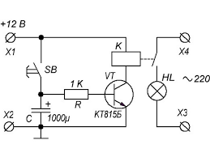

1. **Answer the following questions, according to the scheme:**
2. How many non-electric connections are there?
3. How many earth-protective wires are there?
4. How many circuits parts repetitions are there?
5. How many lamps are there?
6. How many speakers are there?
7. How many busbars are there?
8. How many photodiodes are there?
9. How many capacitors are there?
10. How many switches are there?

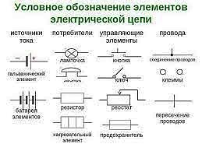

Functional scheme of tape recorder